**Lab report #1**

**Sadovskaya Veronika**

GitHub: https://github.com/sdveronika/DataMola22

**Task 1 - CREATE Storage Objects**

1. Create sa_t_dish

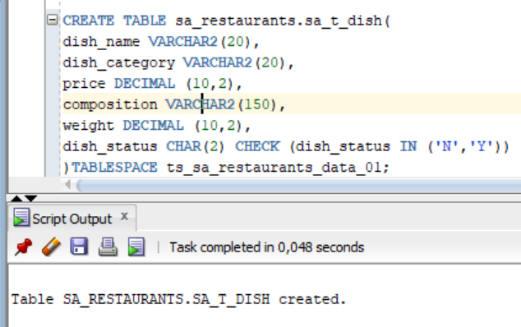

1. Create sa_t_restaurant

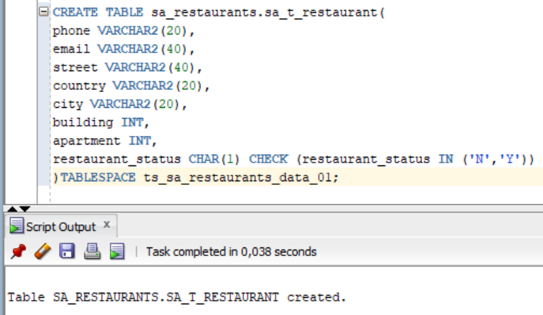

1. Create sa_t_client

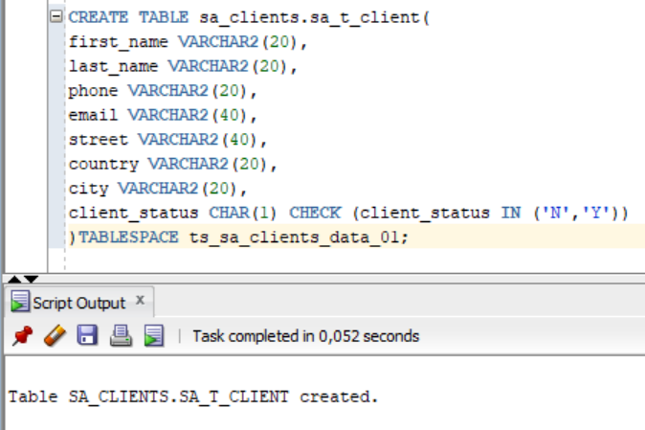

1. Create sa_t_payment_method

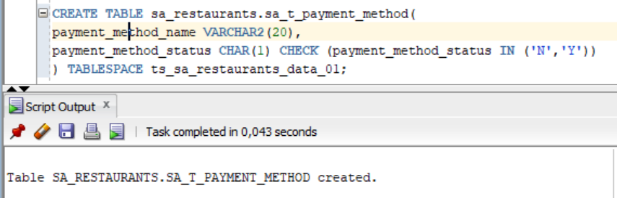

1. Create sa_t_gen_period

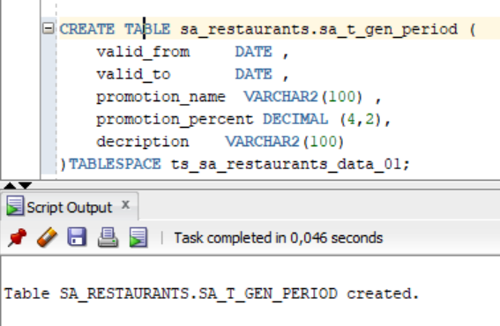

1. Create sa_t_employee

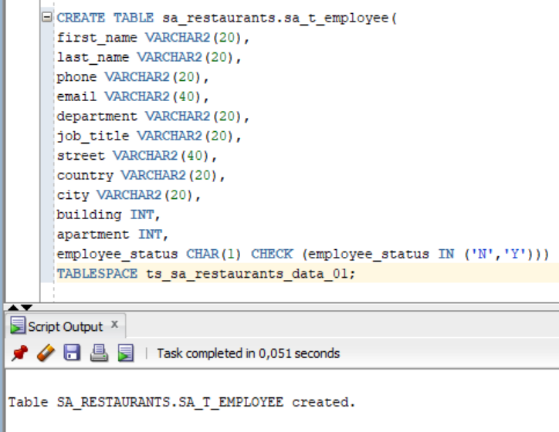

1. Create sa_t_transaction

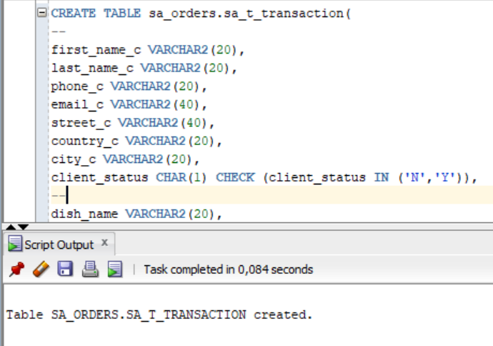

**Task 2 - Generate Test Data in Storage Layers**

1. Generate test data for the table sa_t_dish

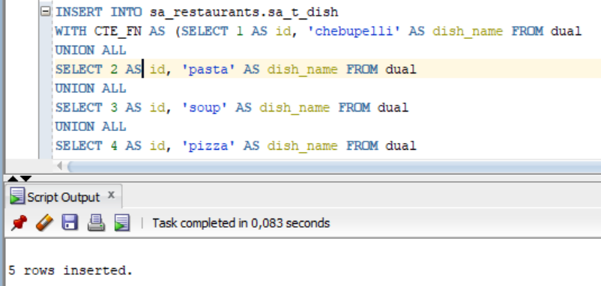

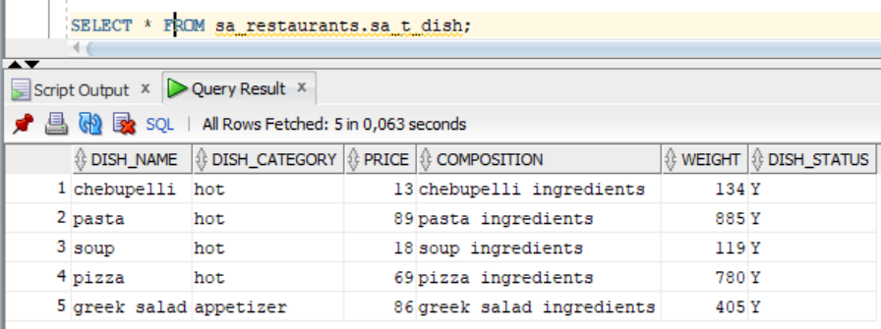

1. Generate test data for the table sa_t_restaurant

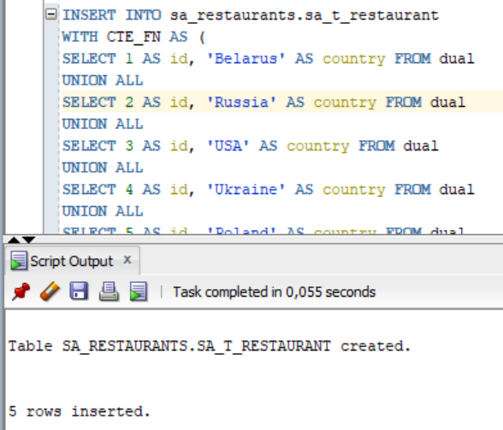

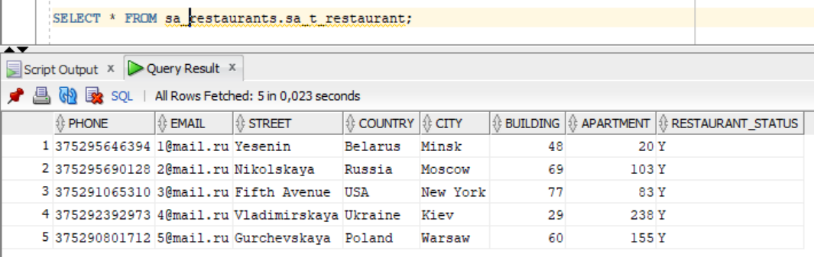

1. Generate test data for the table sa_t_client

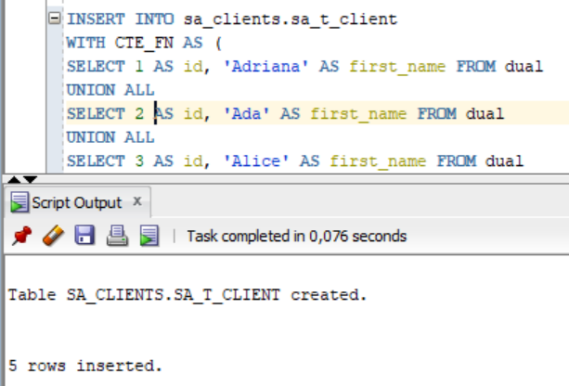

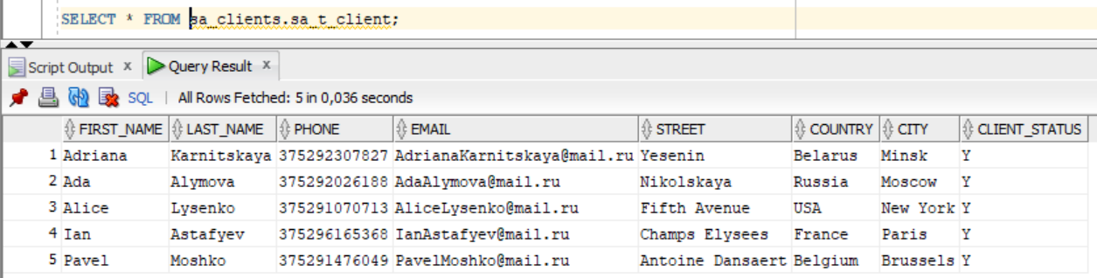

1. Generate test data for the table sa_t_payment_method

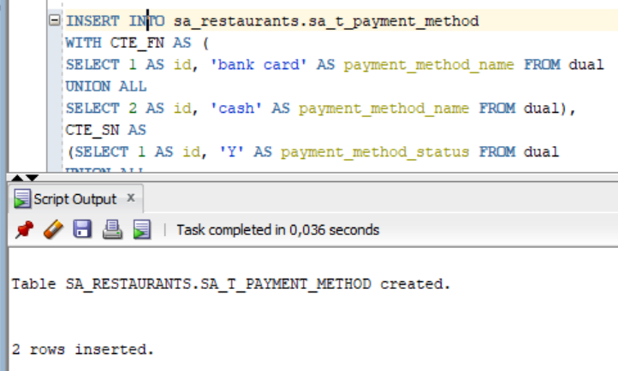

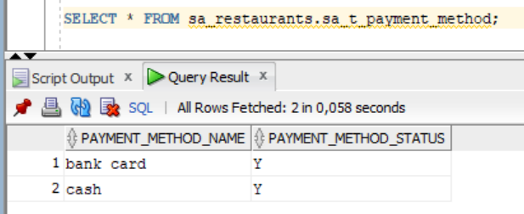

1. Generate test data for the table sa_t_gen_period

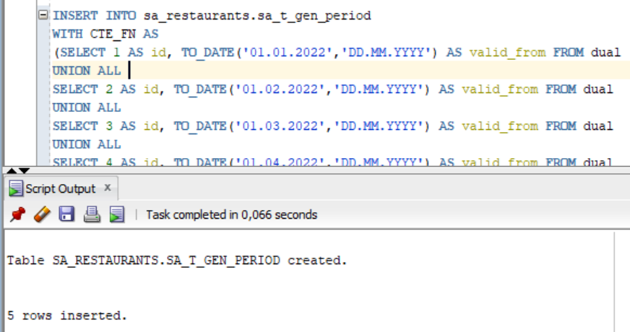

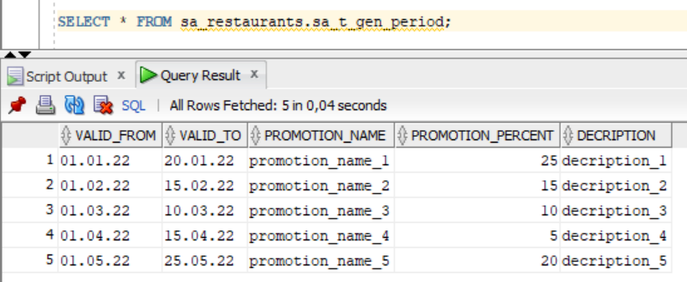

1. Generate test data for the table sa_t_employee

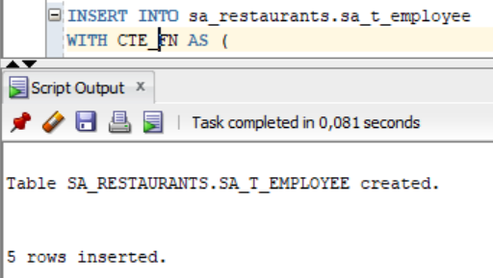

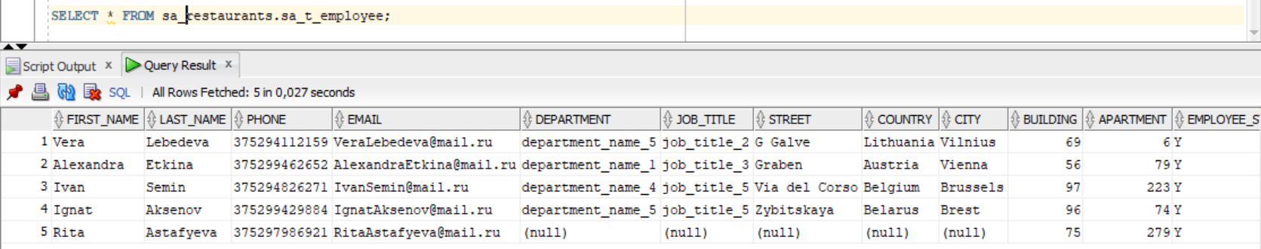

1. Generate test data for the table sa_t_transaction

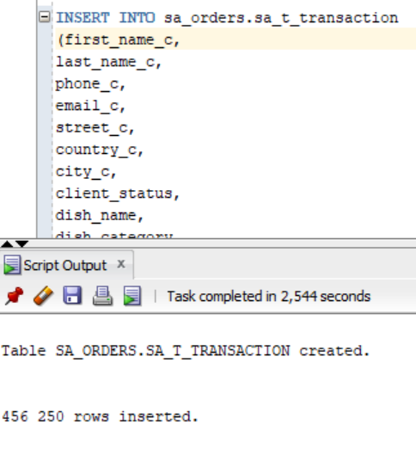

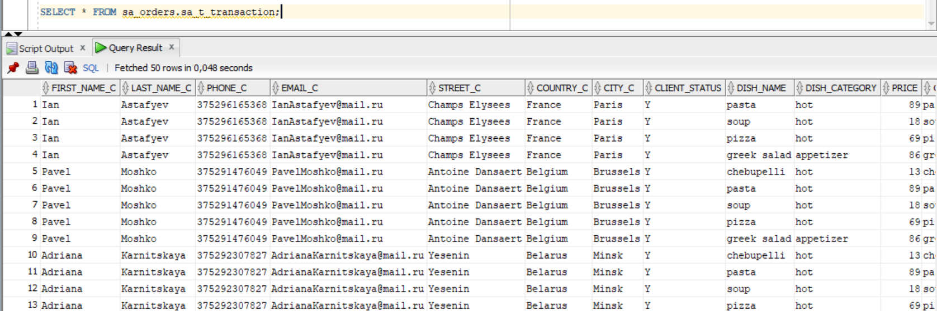

**Task 3 - Create Group by Plan**

